**Lower Granite Dam Adult Fish Trap Water Temperatures.**

During 6-12 September 2019, operation of the adult fish trap at Lower Granite Dam was interupted when water temperatures reached 70°F in the trap, as measured by NOAA Fisheries personnel. At that time the water supply to the trap was via the diffuser 14 supply line and the fishway cooling pump and shower were in operation. During recent FFDRWG regional discussions, questions were raised on how water temperatures in the fishway and trap would be affected if the cooling shower was not operating or if the trap water was being provided by the new supply line from the Juvenile Fish Facility. Figure 1 illustrates the water supply routes to fish facilities at Lower Granite Dam. Figure 2 shows locations of the pertinent water temperature monitoring sites at Lower Granite Dam. Figure 3 provides the hourly water temperatures measured at Lower Granite Dam during September 2019.

***Summary.—***Turning off the fishway cooling shower during the warmest period of September 2019 would have;

***-***Provided ~1 °F cooler water to the adult trap, likely keeping it below the 70 °F threshold,

-Increased the temperature differential between the trap and the fishway to ~ 2 °F and

-Created another differential between diffuser 14 and fishway exit of 1 - 3 °F.

-We do not yet know what water temperatures would be provided to the adult trap via the JFF supply line.

-We speculate JFF water temperatures may be similar to the turbine discharge which would be ~ 1- 3 °F cooler than the diffuser 14 supply. If true, using the JFF supply to the trap,

-Would produce a commensurate increase of 1- 3 °F in the differential between the trap and fishway.

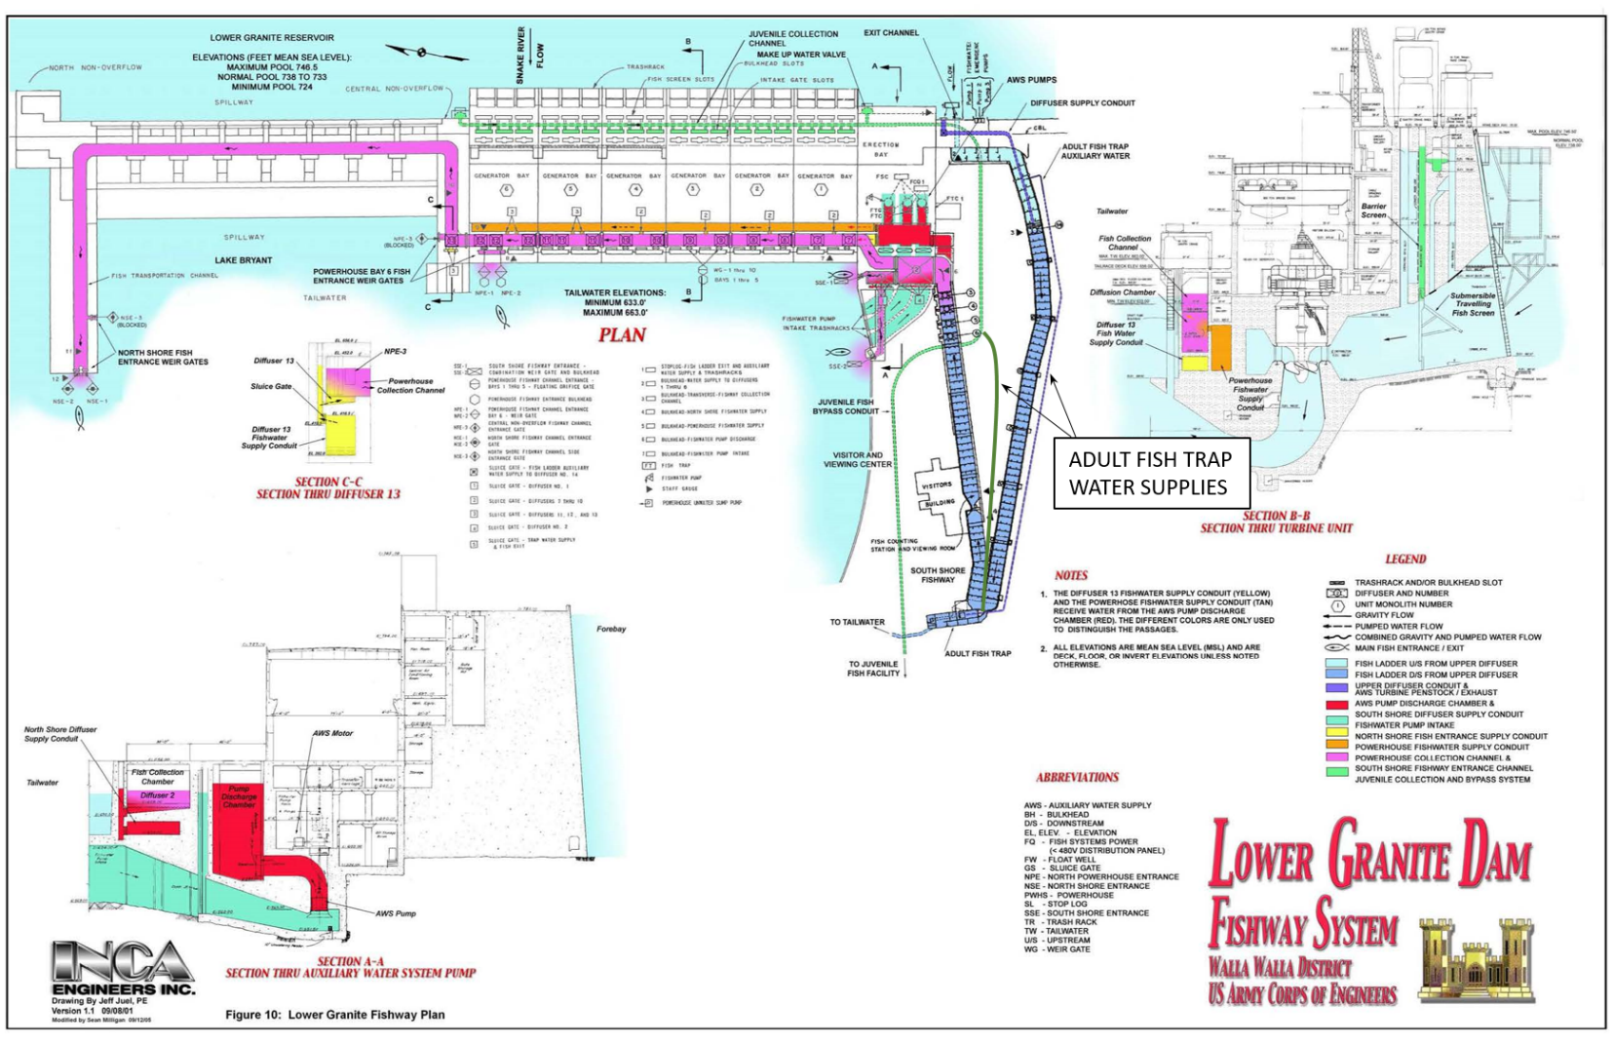

Figure 1. Water supply system for fishway facilities at Lower Granite Dam.

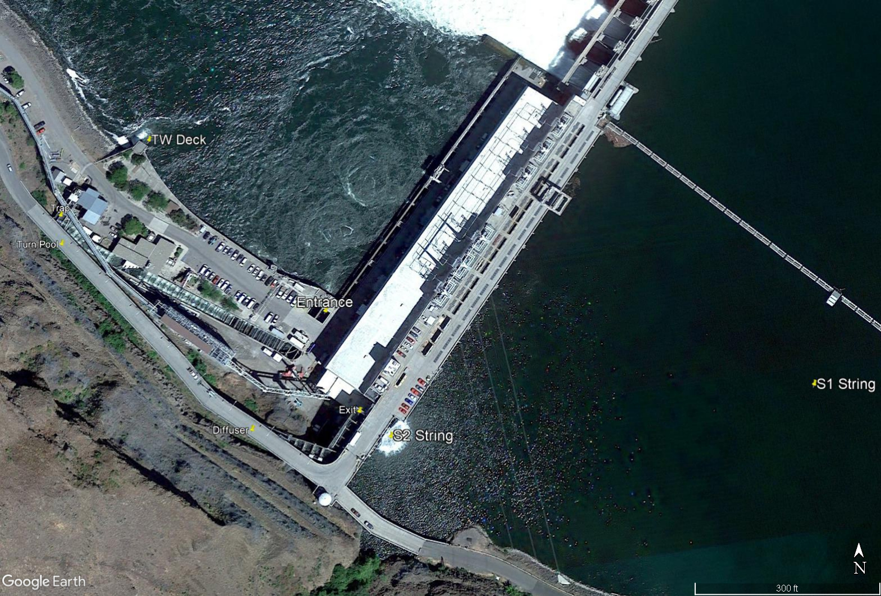

Figure 2. Location of temperature monitoring stations at Lower Granite Dam. String 1 (S1; not correct location) provides the forebay temperature profile not influenced by the fishway cooling pump and shower. String 2 (S2) provides a forebay temperature profile influenced by the fishway cooling pump and shower. Tailwater deck (TW Deck) provides a tailrace temperature influenced by turbine discharge. TW Deck temperatures are slightly cooler than measured at the fishway entrance site.

Figure 3. Hourly temperatures recorded in the Lower Granite Dam fishway during September 2019. See Figure 1 for monitoring locations. Trap temperatures are recorded in the recovery pool of the adult fish trap. Turn pool temperatures are measured in the fishway adjacent to the adult trap and are a mixture of water entering from the forebay at the fishway Exit and flow added to the fishway from diffuser 14. The rectangle indicates the dates (6-12 September) the adult fish trap was out of operation because of warm water temperatures. The brown line shows surface (0.5 m depth) temperatures in the forebay at the S1 string.

***Trap temperature without spray bar operating***

With the chimney in place, water supplied to diffuser 14 is now pulled from about 20 m deep in the forebay, as measured at the 20 m sensor on the S2 forebay string (blue circles Figure 4). If the spray bar were off, water to the trap would not be mixed with shallower water and would likely be similar to the temperatures recorded at the 20 m depth at the S1 forebay string (green circles, Figure 4). By comparing the two trend lines in Figure 4 we can estimate that water supplied to the trap would have been about 1 °F cooler without the spray bar operating last September.

We also estimated fishway temperatures with and without the cooling pump and shower operating. We found that turn pool temperatures in September could be estimated by averaging the 0.5 m and 20 m temperatures at the S2 string, with a slight weighting of the 20 m temperature. Using the same estimator with the S1 data indicated that the fishway temperatures between the diffuser and turn pool would be similar with and without the cooling pump operating (Figure 5). However, without the shower operating, temperatures between the diffuser and fishway exit would have been warmer, reaching as high as 74 °F during September (see S1 0.5m line in Figure 3). During September, trap temperatures were ~ 1 °F cooler than turn pool temperatures (Figure 6). So we estimate that turning off the cooling pump and shower would have resulted in an ~ 2 °F differential between the Lower Granite Dam trap and turn pool, and an additional 1 - 3 °F differential between the diffuser and fishway exit during the warmest period of September 2019.

Figure 4. Temperatures for the Lower Granite Dam adult fish trap and forebay at 20 m depth at the S2 string (blue circles) and corresponding 20 m depth temperatures at the S1 forebay string (green circles).

***Trap temperatures with JFF water supply***

We do not have a firm measure of water temperatures from the JFF as they would be supplied to the adult fish trap. Water to the JFF is a combination of flow into the turbine intakes from a range of forebay depths plus make-up water added to the juvenile collection channel coming from near the forebay surface (see green lines on Figure 1). An approximation of the JFF water temperatures may be those recorded in the fishway entrance, which is dominated by turbine discharged picked up by the fishway pumps. During the warmest period of September, entrance temperatures were 1 - 3 °F cooler than trap temperatures, only reaching 69 °F during a few individual hours (Figure 2). If those data are indicative of the JFF water supply to the trap, trap temperatures would not have reached 70 °F during last September but there may have been differentials as high as 3 °F between the trap and fishway temperatures as recorded at the turn pool.

Figure 5. Estimated vs. actual water temperatures in the Lower Granite Dam fishway turn pool using averaged temperatures from the 0.5 m and 20 m sensors at the S2 (blue) and S1 (green) forebay strings.

Figure 6. Coinciding hourly water temperatures in the Lower Granite Dam adult fish trap and fishway turn pool during September 2019.